RFI Drawings Application Set Up

Add the application from the FIRM folder as “User-defined Command” to the Ribbon.

* C:\Users\user.name\Bourne Group\Bourne Steel - BG2023\BMT Applications\RFIDrawingsApp.exe

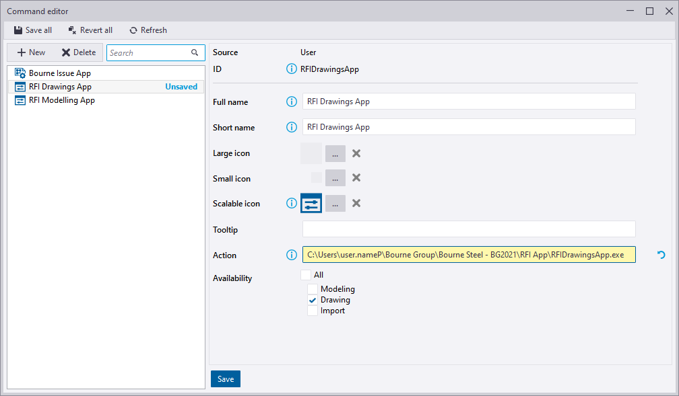

* Add the application as a button to the ribbon.

